LAKE GINKOVO

Vitebsk region, Glubokoe district

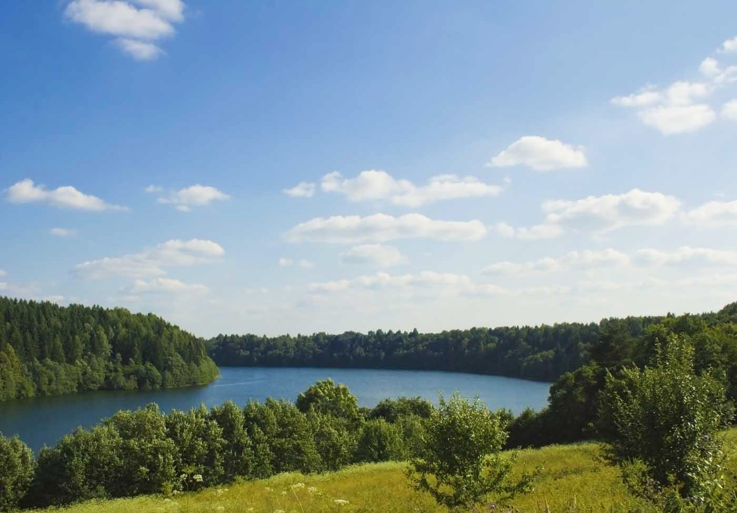

What to do: enjoy the almost mountain scenery and look for the Belarusian cave

This small lake is like a frame from the “Lord of the Rings”: winding and hilly shores, calm water and the coolest energy. What is missing is the main character! There are enough secrets and legends in this place, as well as in the famous film: try to find clues in a local cave - the only one in Belarus. It is small, but you can also see in it the beautiful “puff” landscapes from different breeds - all this was done by nature. Do not forget to turn on the flashlight!

How to get there. By car, your way to Ginkovo ​​will pass through M3, P3 and P45. With public transport it is more difficult: as in the case of Dolgim, we offer you a 683B train to Zyabki station (if you go on another day, get a transfer in Molodechno). Walking will have more than 10 kilometers, but the thirst to see the unique will not stop you!

Where to spend the night. Only three hundred meters from the lake is a former pansky manor, where absolutely everyone can spend the night. The hostess (perhaps of noble blood) is preparing excellent pies - do not miss the opportunity!

LAKE RUDAKOVO

Minsk region, Myadel district

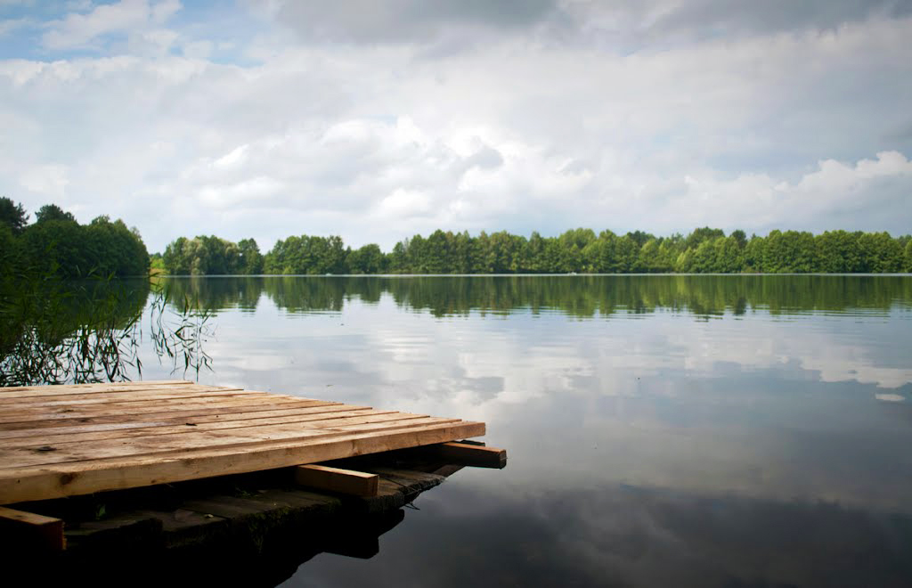

What to do: swim in the cleanest water

While everyone is riding on Naroch, there is a cozy little lake Rudakovo with clear water and an excellent view - you need to go, and then the visitors of the famous neighbor can change their mind! In addition, some water in the lake is healing: silver impurities were found in it (according to legend, the church went under the water). But not forbidden to swim, on the contrary, actively recommend!

How to get there. We think the way towards Myadel, you know, but just in case, we remind you: drive a couple of hours by P58 by car, buses run several times a day (see here)

Where to spend the night. There are plenty of housing options: you can book a holiday voucher to the recreation center (13 days) and have a great holiday, spend the night in a nice homestead near the lake or stay in Myadel itself, and from there drive on greats - in any case it will be cool!

LAKE GUMMER

Vitebsk region, Ushachy district

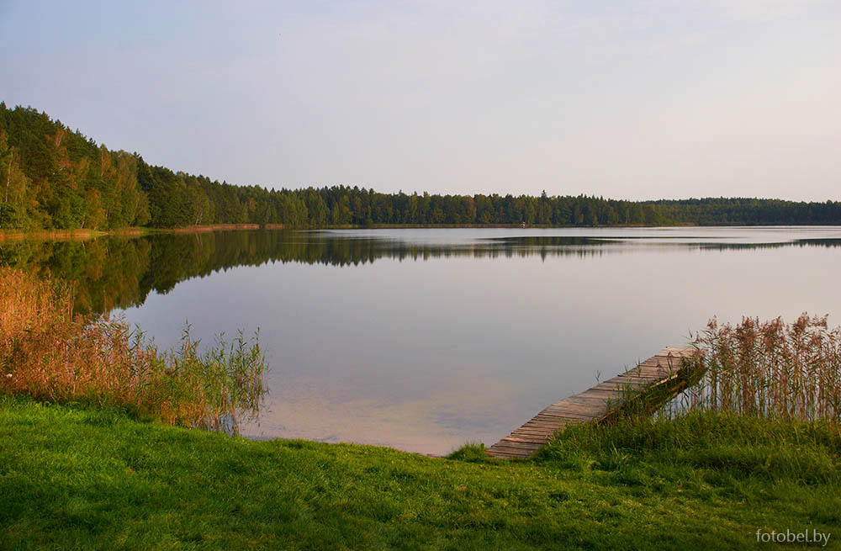

What to do: catch the cancer with blue color

Another great place in the north for last. The real blue cancer can be caught only in Australia or New Guinea, but in Belarus there are places where minerals force them to change the color of the shell (for masking): from green to blue. It is possible to see and even catch (if you're lucky, of course) such exotics in Lake Borovenok: the taste of the animal, by the way, will be familiar. If the cancer stubbornly backs away, you can just swim in the lake - it's beautiful there! By the way, the “Breakthrough” memorial complex is very close - look inside the cultural program.

How to get there. The car route is based on your usual M3 and P46, here are the GPS coordinates just in case: 55.215829, 28.480703. Getting to the lake by car is the best option, because the bus will have to make three transfers: first in Vitebsk, then in Ushachi, see the entire route here.

Where to spend the night. In this case, it is best to take a tent and sit right on the spot - isn’t the best option in good weather? Yes, and just cook fresh crayfish.